Project Design Phase
Problem – Solution Fit
Date | 04 September 2026
Student Name | Pulibanti Tejavani
Project Name | Metro Ticket Generating System
Maximum Marks

Problem–Solution Fit
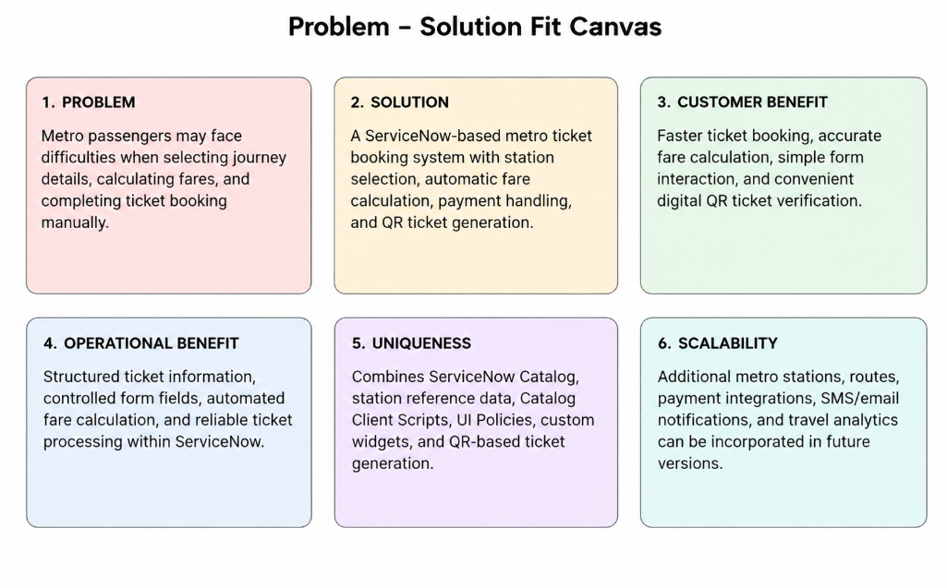Figure 1: Problem–solution fit canvas for the Metro Ticket Generating System.
Parameter | Project Fit
Problem | Metro passengers need a simple and reliable way to select stations, enter journey details, and obtain the correct ticket fare.
Solution | A ServiceNow-based metro ticket booking system with a guided catalog form, automatic fare calculation, payment handling, and QR ticket generation.
Customer Benefit | Simplifies ticket booking by reducing manual fare calculation and providing a digital QR-based ticket for verification.
Operational Benefit | Stores booking details in ServiceNow and provides structured information for ticket processing and validation.
Uniqueness | Combines ServiceNow Catalog, dependent station selections, client-side fare automation, UI policies, and QR-code generation in one workflow.
Scalability | The system can later support additional stations, fare routes, payment integrations, SMS/email tickets, and travel analytics.

